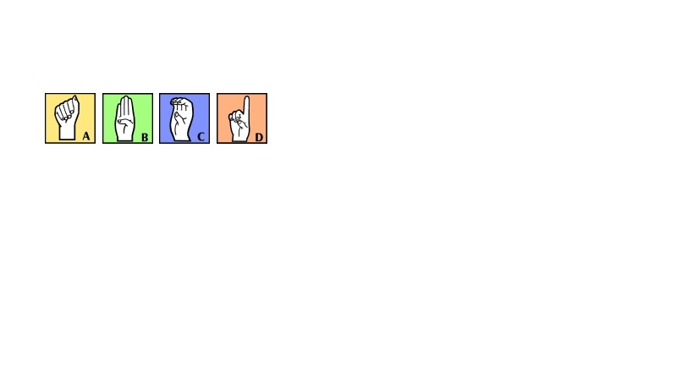
.

ASL 1 – American Sign Language
Mount Si High School
2015 -2016
Please keep this for
further reference
throughout the year.

Teacher: Lindsay Greene
Email: greenel@svsd410.org
Room: 302/917
Website: lindsaygreene.weebly.com
COURSE DESCRIPTION & GOALS
Course Description: This course is an introduction to American Sign Language (ASL) and the community of people who use it. As a second language, ASL 1 covers fundamental issues of basic human language, grammar and communication. Above all, it is a class that requires your attendance, involvement, and practice. Success in this class will bring you valuable skills which will allow you to interact with another culture, by introducing you to a unique, diverse, rich culture that coexists throughout North America, namely the Deaf community. This will enable you to broaden your understanding of deaf culture, communication, and language. ASL is a foreign language accepted by many colleges and universities all over the country.
Educational Philosophy: ASL cannot simply be learned in the classroom. It takes outside practice and exposure to others who sign. You will be given opportunities for learning in class, before and after school, and within the community. The more you put into my class the more you will get out of it. The possibilities are limitless.
Learning Environment: I hope that you will commit to creating a classroom environment which will accommodate persons of diverse backgrounds, experiences and needs. If you are able to appreciate, respect, and benefit from the varied personalities and behaviors of your peers, then you will be better prepared to do the same with the myriad encounters you will have with members of the Deaf community and our society as a whole.
Course Goals: During this year you will be asked to demonstrate your (1) receptive and expressive accuracy in and/or knowledge of each of the following grammatical, functional, and cultural components of ASL:
Grammatical Components
Core Vocabulary – Signing Naturally Units 1-6
Manual Alphabet – Finger Spelling
Numbers – Cardinal Numbers, Ordinal Numbers 1-9, Ages, Ranking
Dominant/non-dominant hand use
Non-Manual Grammatical Signals (NMGS)
Sentence Types – Declaratives, Negatives, Wh-questions, Yes/No questions, Imperatives (commands), Topicalization
Spatial Agreements – Eye-gaze
Real World Orientation and Signer’s Perspective
ASL Time Line and Time Indicators
Functional Components
Introducing Oneself
Describing Locations/Surroundings
Responding, Confirming, Negating
Exchanging Personal Information
Describing Family and Relatives
Cultural Components
History of ASL
Deaf Culture and the Deaf Community

REQUIRED MATERIALS
Technology: Daily access to computer with CD Drive/ DVD Player with TV. You will be using these to complete your homework. If this is an issue please talk with me and we can set up and time for you to complete it at school using a school computer. This may mean coming in early, or staying after school.

Textbooks:
Signing Naturally Student Workbook and Videotext Units 1-6: Lenz, Mikos, Smith; Dawn Sign Press, second edition.'

Website:
http://lindsaygreene.weebly.com/
You will find all course documents, homework and resources here!

1/2in -1in. three ring binder exclusively for ASL.
3 dividers

SUPPLEMENTAL MATERIALS
Sign Language Dictionary (I will have copies available in the classroom):: There are several sign language dictionaries available at bookstores and libraries. There is no one complete ASL dictionary, and some signs vary from book to book. Look for one that you find useful and easy to understand.
For Hearing People Only (FHPO) (I will have copies available in the classroom):
This text will come in handy as you progress through your ASL courses.

Author: Matthew S. Moore and Linda Levitan

Edition/Copyright: 3RD 03
Cover: Paperback
Publisher: Deaf Life Press
Year Published: 2003
EVALUATION AND GRADING
Assignments – Homework will be a regular occurrence. It should not take you more than15- 20 min a night.
Assignments will include the Signing Naturally workbook and video assignments, summaries, and other assignments as carried out through the year. These will vary from 5-15 points.
Quizzes – There will be weekly quizzes. These quizzes will cover material from Signing Naturally, class discussion and Readings from FHPO and other sources.
Main Campus- If you are absent for a quiz (Fridays), the makeup will be Monday at 2:20 pm. Please make arrangements with your ride to school to make it here on time. If you cannot make it please contact me in advance.
Frosh. Campus- If you are absent for a quiz (Fridays), the makeup will be Monday at 7:25 pm. Please make arrangements with your ride to school to make it here on time. If you cannot make it please contact me in advance.
Exams- Exams will be given throughout the year. These will be comprehensive for everything that has been covered since the beginning of the year. ASL builds upon itself, therefore anything that has been discussed in class, on homework, or in assigned readings will be fair game.
If you are absent for an exam, the makeup date is the next day you are in school at 7:15 am (Frosh. Campus) and 2:25 pm (Main Campus). Please make arrangements with your ride to school to make it here on time or for pickup after school.
Projects- Projects will be assigned though out the year. They will emphasize the current and past units of study.
Cultural Experience- You will be asked to attend 3 deaf events per semester. There is a comprehensive list of reoccurring events on my web page and I will notify you are special events come up. You also may want to join the Bellevue College ASL Club Facbook page.
PRESENTATIONS
There will be presentations throughout the year. The information will be posted on the class website. You will be given at least a week notice for each presentation. There will be a chance to sign up for a day to present. You will be able to choose your presentation date, however if you do not sign up I reserve the right to add you to the schedule where ever there are gaps in order to have everyone present in a timely manner.
If you are absent on the day of your presentation, you must have documentation per the school's absence policy in order to make up your presentation. You will make up your presentation on the next day you are in school or when there is time in the presentation schedule. This very well could be after everyone else has gone. You will need to be prepared to present on demand.
GRADING POLICY
Grading- I do my best to get grading done daily. However, there are times when meetings, conferences and other responsibilities may delay a grade getting in. It is my personal goal to never have an assignment take more than 5 school days to get into the grade book.
Late Assignments- Late assignments will be accepted for 1/2 credit until the end of the each quarter.
Missed Quizzes/ Assignments – All make-up work is the responsibility of the student. You must check in with me (before or after class) and on the website to get handouts or other materials. I will not track you down.
CELL PHONE POLICY
I appreciate the need for cell phones in our society today. However, there is no need to use them in my classroom, unless directly instructed. I will give a warning, after that, the second offense will result in an office referral for a 1hour detention.

Student Name:__________________________________________

American Sign Language 1
Lindsay Greene
Room 302/ Room 917

Please return with both the signature of the student and a parent or guardian’s. Parents please do not hesitate in contacting me with any questions or concerns. By signing this page you are stating that you have read and understand the contents of the syllabus.

The return of this paper will count for a 10 point homework assignment.
Please return this by September 7th, 2015.

X
Parent Signature Date
Parent Phone Number: ________________________________________
Parent Email: ________________________________________________________

X
Student Signature Date

