 | Date Complete | Teacher Sign Off
7.1
7.2
7.3
7.4
7.5
7.6
7.7
7.8
7.9
7.10
7.13
Unit Review

 | Date Complete | Teacher Sign Off
8.1
8.2
8.3
8.6
8.7
8.8
8.9
8.10
8.11
8.12
8.13
8.14
Unit Review

 | Date Complete | Teacher Sign Off
9.1
9.3
9.4
9.5
9.7
9.8
9.9
9.10
9.11
9.12
9.14
Unit Review

 | Date Complete | Teacher Sign Off
10.1
10.2
10.3
10.4
10.5
10.6
10.7
10.8
10.9
10.11
Unit Review

 | Date Complete | Teacher Sign Off
11.1
11.2
11.3
11.4
11.5
11.6
11.8
11.9
11.10
11.11
Unit Review

 | Date Complete | Teacher Sign Off
12.1
12.3

Name:______________________________________________________ Period:____________________

Name:_______________________________ Date:_________________________ Period:____________

7.1
Refer to textbook pages 4-13.
Minidialogue 1
- How does David identify his uncle?

- What additional information do Iva and David give to confirm they are talking about the same person?

- What explanation does David give for his uncle’s appearance?

- How does Iva identify the second man?

- What does Iva think of him?

Minidialogue 2
- What comment does Tonique make about Ursula’s brother?

- Why did the brother change his appearance?

- What does he also do?

Name:_______________________________ Date:_________________________ Period:____________

7.2
Please refer to textbook pages 14-16.

- _____________________________
- _____________________________
- _____________________________
- _____________________________
- _____________________________
- _____________________________
- _____________________________
- _____________________________
- _____________________________
- _____________________________
- _____________________________
- _____________________________
- _____________________________
- _____________________________
- _____________________________
- _____________________________
- _____________________________
- _____________________________
- _____________________________
- _____________________________
- _____________________________
- _____________________________

Name:_______________________________ Date:_________________________ Period:____________
7.3
Please Refer to pages 17-19

GUESS MY NUMBER
- _____________________ above below between
- _____________________ above below between
- _____________________ above below between
- _____________________ above below between
GUESS MY NUMBER 2
1)_____________________ above below between
2)_____________________ above below between
3)_____________________ above below between
4)_____________________ above below between
5)_____________________ above below between
6)_____________________ above below between
7)_____________________ above below between
8)_____________________ above below between
GUESS MY NUMBER 3
1)_____________________ above below between
2)_____________________ above below between
3)_____________________ above below between
4)_____________________ above below between
5)_____________________ above below between

Name:_______________________________ Date:_________________________ Period:____________
7.4
Please refer to pages 20-34
Minidialogue 1
- How did Urusla get the item? _______________________________________________
- Draw or describe the item. ________________________________________________________________________________________________________________________________________________
________________________________________________________________________
- What is it made of? _______________________________________________________
- What did Urusla think of it? _________________________________________________
Minidialogue 2
- How did Terrylene get the item? _____________________________________________
- Draw or describe the item. ________________________________________________________________________________________________________________________________________________
________________________________________________________________________
- What is it made of? _______________________________________________________
- What did Terrylene think of it? ______________________________________________

Minidialogue 3
- How did Justin get the item? _____________________________________________
- Draw or describe the item. ________________________________________________________________________________________________________________________________________________
________________________________________________________________________
- What is it made of? _______________________________________________________
- Describe the costume. _____________________________________________________

Minidialogue 4
- How did Lauren get the item? _____________________________________________
- Draw or describe the item. ________________________________________________________________________________________________________________________________________________
________________________________________________________________________
- What is it made of? _______________________________________________________
- When Suzanne asked Lauren is she liked the sunglasses, why do you think Lauren didn’t reply to the question directly? ______________________________________________

Name:_______________________________ Date:_________________________ Period:____________
7.5
Please Refer to pages 35-38

________ 1. I have no money
________ 2. I have a car.
________ 3. I already had cake.
________ 4. I haven’t told Jose
________ 5. I have to tell Jose.
________ 6. I have told Jose.
________ 7. I have a HDTV.
________ 8. I have to buy a jacket.
________ 9. I have done my homework.
________ 10. I have to call my mother.
________ 11. I don’t have any ice cream.
________ 12. I didn’t have any ice cream.

Name:_______________________________ Date:_________________________ Period:____________
7.6
Please refer to pages 39-44

- Write the Translation
_______________________________________________________________________________________________________________________________________________
- Write the Translation
________________________________________________________________________________________________________________________________________________
- Write the Translation
________________________________________________________________________________________________________________________________________________
- Write the Translation
________________________________________________________________________________________________________________________________________________
- Write the Translation
________________________________________________________________________________________________________________________________________________

Name:_______________________________ Date:_________________________ Period:____________
7.7
Please refer to pages 35-46

 | Topics | Number Given | Reaction Used
1.
2.
3.
4.
5.
6.
7.
8.
9.
10.
11.
12.
13.
14.
15.

Name:_______________________________ Date:_________________________ Period:____________
7.8
Please refer to pages 47-52
Please use page 48 - 50 to complete the exercise below!
For 1-6
Black Purse | Blue Backpack | Green and tan messenger bag
Man wearing California Shirt | Man in tan collared shirt | Man w/ arms crossed in blue
White baseball cap | Tan fisherman’s hat | Tasseled snow cap

For 7-12
Girl Polka Dot Scarf | Girl with plaid scarf | Girl with multi-color scarf
Girl with fur trimmed hood | Girl with mittens | Girl with black coat
White sunglasses | Aviators | Black sunglasses

Name:_______________________________ Date:_________________________ Period:____________
7.9
Please refer to pages 53-56

WRITE THE YEAR

EVENT | YEAR
The sinking of the titanic.
Start of WW1
Wright Brothers first engine flight.
Young women’s hair styles of that period
First x word puzzle
First Ford car sold
Barak Obama is elected president of the US
Hippie clothing is popular
San Francisco earthquake and fire
London, England hosted the summer Olympics.

Name:_______________________________ Date:_________________________ Period:____________
7.10
Please refer to pages 57

1.______________________________________________________________________

2.______________________________________________________________________

3.______________________________________________________________________

4.______________________________________________________________________

5.______________________________________________________________________

6.______________________________________________________________________

7.______________________________________________________________________
8.______________________________________________________________________

Name:_______________________________ Date:_________________________ Period:____________
7.13
Please refer to pages 64-68
STORY: A MEMORABLE COSTUME
- How old were Amber and her brother?

- What traditionally happens a school for Halloween?

- One Halloween, what did Amber and her brother want to be?

- Explain what they did to make the costume?
- The head

- The body

- What did they win?

Name:_______________________________ Date:_________________________ Period:____________
8.1
Please refer to pages 74-85

MINIDIALOGUES

Minidialogue 1
Signer A
Explain the situation_______________________________________________________
Request made____________________________________________________________

Signer B
Reason for declining_______________________________________________________

Minidialogue 2
Signer A
Explain the situation_______________________________________________________
Request made____________________________________________________________

Signer B
Reason for declining_______________________________________________________

Minidialogue 3
Signer A
Explain the situation_______________________________________________________
Request made____________________________________________________________

Signer B
Reason for declining_______________________________________________________
Suggested Solution________________________________________________________

Minidialogue 4
Signer A
Explain the situation_______________________________________________________
Request made____________________________________________________________

Signer B
Reason for declining_______________________________________________________

Minidialogue 5
Signer A
Explain the situation_______________________________________________________
Request made____________________________________________________________

Signer B
Reason for declining_______________________________________________________
Suggested Solution________________________________________________________
Minidialogue 6
Signer A
Explain the situation_______________________________________________________
Request made____________________________________________________________

Signer B
Reason for declining_______________________________________________________
Suggested Solution________________________________________________________

Name:_______________________________ Date:_________________________ Period:____________
8.2
Please refer to pages 86-93
Month(s) | What the month(s) refer to
1.
2.
3.
4.
5.
6.
7.
8.

Name:_______________________________ Date:_________________________ Period:____________
8.3
Please refer to pages 94-98

SENTENCES
Sentence 1
“ I told Rene to send you the flowers but instead she sent them to me.”
A __ B__
Write the English translation for the other signed sentence:
________________________________________________________________________________________________________________________________________________
Sentence 2
“Lee called to tell me you have not paid him.”
A __ B__
Write the English translation for the other signed sentence:
________________________________________________________________________________________________________________________________________________
Sentence 3
Renee informed me that Lee already paid her, so now I will end Lee the package.”
A __ B__
Write the English translation for the other signed sentence:
________________________________________________________________________________________________________________________________________________
NARRATIVES
Narrative 1
What did the dentist call JT about? ________________________________________________________________________________________________________________________________________________
What was JT’s response?
________________________________________________________________________________________________________________________________________________
Narrative 2
What did Suzanne buy and when will it be delivered?
________________________________________________________________________________________________________________________________________________
What happened when she got ready to pay?
________________________________________________________________________________________________________________________________________________

Name:_______________________________ Date:_________________________ Period:____________
8.6
Please refer to pages 109-113
WRITE THE PHONE NUMBER
- _______________________________ For the White House switchboard
- _______________________________ For the NY U.S. Senator’s office
- _______________________________ For the NAD office
- _______________________________ For the DawnSign Press, Inc.’s office
USEFUL NUMBERS
411_____________________________________________________________________________________________________________________________________________
511_____________________________________________________________________________________________________________________________________________
611_____________________________________________________________________________________________________________________________________________
911_____________________________________________________________________________________________________________________________________________

Name:_______________________________ Date:_________________________ Period:____________
8.7
Please refer to pages 114-119
Minidialogue 1

- Situation?

- What was forgotten?

- Advice Given?

Minidialogue 2

- Situation?

- What was forgotten?

- Advice Given?

Minidialogue 3

- Situation?

- What was forgotten?

- Advice Given?

Name:_______________________________ Date:_________________________ Period:____________
8.8
Please refer to pages 114-119

Concept | Strategy
1.

2.

3.

4.

5.

6.

7.

8.

9.

10.

Name:_______________________________ Date:_________________________ Period:____________
8.9
Please refer to pages 122-125

Narrative 1 _______________________________________________________________________________________________________________________________________________________________________________________________________________
Narrative 2
_______________________________________________________________________________________________________________________________________________________________________________________________________________
Narrative 3 _______________________________________________________________________________________________________________________________________________________________________________________________________________
Narrative 4 _______________________________________________________________________________________________________________________________________________________________________________________________________________
Narrative 5 _______________________________________________________________________________________________________________________________________________________________________________________________________________

Name:_______________________________ Date:_________________________ Period:____________
8.10
Please refer to pages 126-133
Minidialogue 1

Situation?

What was forgotten?

Advice Given?

Minidialogue 2

Situation?

What was forgotten?

Advice Given?

Minidialogue 3

Situation?

What was forgotten?

Advice Given?

Name:_______________________________ Date:_________________________ Period:____________
8.12
Please refer to pages 136-139

THE MOTEL STORY
Write a summary and explain why the story was funny.
______________________________________________________________________________________________________________________________________________________________________________________________________________________________________________________________________________________________________________________________________________________________________________________________________________________________________________________________________________________________________________________________________________________________________________________________________________________________________________________________________________________________________________________________________________________________________________________________________________________________________________________________________________________________________________________________________________________________________________________________________________________________________________________________________________________________________________________________________________________________________________________________________________________________________________________________________________________________________________________________________________________________________________________________________________________________________________________________________________________________________________________________________________________________________________

Name:_______________________________ Date:_________________________ Period:____________
8.14
Please refer to pages 142-147

EUGENE’s CHANGING NAME SIGNS

- What name sign did Eugene’s parents give him?

- In Grade School his name sign changed. Why and how?

- At Gallaudet U, how did students refer to each other?

- At Eugene’s first job, what name sign did the children give to him? Why?

- At Eugene’s second job, what name sign did the children give to him? Why?

- At Eugene’s third job, what name sign did the children give him? Why?

- What name sign did Eugene end up with and why?

Name:_______________________________ Date:_________________________ Period:____________
9.1
Please refer to pages 154-167
DESCRIBE A NEIGHTBORHOOD
Amber’s Neighborhood
- Where Amber lives
  - Kind of residence, what city or district _______________________________
  - For how long and who with________________________________________

- Tell what Amber’s neighborhood is like
  - Type of neighborhood or area______________________________________
  - What is nearby and convenient_____________________________________
  - Who lives in her neighborhood_____________________________________
- What is next door to her residence______________________________________
- What she likes and does not like about the area ________________________________________________________________________________________________________________________________________________
- About her future plans_____________________________________________________

Name:_______________________________ Date:_________________________ Period:____________
9.3
Please refer to pages 174-176

WRITE THE TIME

- ______________
- ______________
- ______________
- ______________
- ______________
- ______________
- ______________
- ______________
- ______________
- ______________
- ______________
- ______________
- ______________
- ______________
- ______________
- ______________
- ______________
- ______________
- ______________
- ______________

FILL IN THE TIME
Activity and Places | Time 1 | Time 2
1.
2.
3.
4.
5.
6.

Name:_______________________________ Date:_________________________ Period:____________
9.5
Please refer to pages 184-188

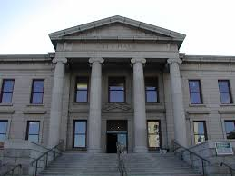
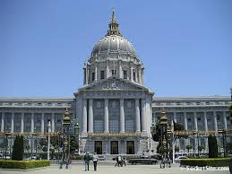

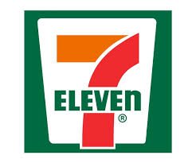

Name:_______________________________ Date:_________________________ Period:____________
9.7
Please refer to pages 193-209

DESCRIBING RESTURANTS
Restaurant 1

- Name of restaurant________________________________________________

- Dining area location ________________________________________________
- Draw the tables and their arrangements:

- Draw the arrangement of the boats and the fish sculptures:

- Draw the arrangement of the surfboards:

- Type of food served at the restaurant___________________________________

Restaurant 2
- Name of restaurant___________________________________________________

- What is seen before reaching the restaurant? _____________________________

- What the restaurant used to be_________________________________________

- Fill in the room with details:

- Type of food served at the restaurant________________________________

Name:_______________________________ Date:_________________________ Period:____________
9.8
Please refer to pages 210-212

2
1

Name:_______________________________ Date:_________________________ Period:____________
9.9
Please refer to pages 213-215
Time | Who | What Happens
1.

2.

3.

4.

5.

6.

7.

8.

9.

10.

Name:_______________________________ Date:_________________________ Period:____________
9.10
Please refer to pages 216-221

SUGGESTING A PLACE TO EAT
Minidialogue 1
- Who does Suzanne want to take out to eat? ____________________________
- Describe each restaurant.
Amber’s recommendation
Name: _______________________________________
Info Given:

Drawback:

Lauren’s recommendation
Name: _______________________________________
Info Given:

Drawback:

- Why does Lauren think amber’s recommendation is not ideal?
- Which restaurant does Suzanne decide on why?
- Why does Amber disagree with Suzanne’s choice of restaurant?

Name:_______________________________ Date:_________________________ Period:____________
9.11
Please refer to pages 222-229

Name of Business | Reason for going
1.

2.

3.

4.

5.

6.

7.

8.

Name:_______________________________ Date:_________________________ Period:____________
9.12
Please refer to pages 227-229
Underline the topic of each question.
- Do you like meeting new people?
- Do you like foreign Films?
- Have you tried eating raw fish?
- Have you ever experienced raising a rabbit?
- Do you write poetry?
- Do you know how to scan pictures into the computer?
- Can you cross your eyes?
- Have you ever tried snowboarding?
- Can you name three famous painters (artists)?

Name:_______________________________ Date:_________________________ Period:____________
9.14
Please refer to pages 232-237

The Hitchhiker
- Describe the hitchhiker.

- Describe the driver.

- How do the hitchhiker and the driver communicate with each other?

- Where does the hitchhiker want to go?

- What does the driver see in the rearview mirror?

- Why is he pulled over?

- How do the driver and cop communicate?

- What do the driver and the cop say to each other?

- What is the hitchhiker’s reaction?

- Why do the two switch places?

- How fast is the second driver going when stopped by the policeman?

- When the second driver is stopped by the police, what does he plan to do?

- Why does his plan not work?

- What does he get?

- What can we learn from this story?

Name:_______________________________ Date:_________________________ Period:____________
10.1
Please refer to pages 242-251

Minidialogue 1
- Why does John suggest to David they trade roommates?

- Why do you think David responds the way he does?

Minidialogue 2
- What is it about their bosses that cause Ursula to suggest she and Tonique find new jobs?

- What other complaint about their jobs is implied at the end of the conversation?

Minidialogue
- Describe David and Iva’s children:
David:

Iva:

- Compare the children’s teachers.

Please prepare the assignment on page 245 DEINE THESE WORDS and be ready to share in class.

Name:_______________________________ Date:_________________________ Period:____________
10.2
Please refer to pages 252-258
Write the Amount

- _____________________
- _____________________
- _____________________
- _____________________
- _____________________
- _____________________
- _____________________
- _____________________
- _____________________
- _____________________
- _____________________
- _____________________
- _____________________
- _____________________
- _____________________
- _____________________
- _____________________
- _____________________
- _____________________
- _____________________
- _____________________
- _____________________
- _____________________
- _____________________

How Much
 | Item | Amount
1.
2.
3.
4.
5.
6.
7.
8.
9.
10.
11.
12
Name:_______________________________ Date:_________________________ Period:____________
10.3
Please refer to pages 259-260

WH- Word Questions 1
Underline the topic of each question.
- How much does a baseball bat cost?
- What is the number that comes after 67?
- What activities do you have to do in the next few days?
- Why is talking not allowed in class?
- How do you get money from an ATM?
- Who are you closer to – your mom or dad?
- Who invented the light bulb?
- What happened when Gallaudet
- What two colors make green?
- Which day of the week do you like best?

Name:_______________________________ Date:_________________________ Period:____________
10.4
Please refer to pages 261-270

Minidialogue 1
- What was Iva’s initial opinion about John and what situation does she describe to support the opinion?

- What explanation does John give to Tonique that corrects Iva’s misperception of him?

Minidialogue 2
- How are Melvin’s partner and Derrik’s girlfriend different when they are traveling?

- What situations do Melvin and Derrick describe to support their opinions?

- Where is Derrik flying to?

Minidialogue 3
- What have others told Amber about the LSF teacher, LaRue?

- What opinion does Lauren have about the teacher? How does she describe the class experience?

- What is ambers decision about taking the class?

Name:_______________________________ Date:_________________________ Period:____________
10.5
Please refer to pages 271-276
Write the Amount

- ______________
- ______________
- ______________
- ______________
- ______________
- ______________
- ______________
- ______________
- ______________
- ______________
- ______________
- ______________
- ______________
- ______________
- ______________
- ______________
- ______________
- ______________
- ______________
- ______________
- ______________
- ______________
- ______________
- ______________

Milk  ________________ | Cheese  ________________ | Bread  ________________ | Butter  ________________ | Eggs  ________________
Tomato  ________________ | Onion  ________________ | Banana  ________________ | Apple  ________________ | Orange  ________________
Peanut Butter  ________________ | Strawberry Jam  ________________ | Mayo  ________________ | Yogurt  ________________ | Soup  ________________
Bacon  ________________ | Hot Dog  ________________ | Cheerios  ________________ | Tea  ________________ | Sugar  ________________
Ice Cream  ________________ | Cookie  ________________ | Cracker  ________________ | French Fries  ________________ | Lettuce  ________________

Name:_______________________________ Date:_________________________ Period:____________
10.6
Please refer to pages 277-280

CIRCLE THE NUMBER

- 1 2 3
- 1 2 3
- 1 2 3
- 1 2 3
- 1 2 3
- 1 2 3
- 1 2 3
- 1 2 3

Name:_______________________________ Date:_________________________ Period:____________
10.7
Please refer to pages 281-286
USE PICTURE ON PAGE 282- Instead of writing the number in the picture please give a short description of where the item is located.
 | Item | Reason for Request | Location of Item
1.
2.
3.
4.
5.
6.

Name:_______________________________ Date:_________________________ Period:____________
10.8
Please refer to pages 287-289

Circle the topic and underline the choices listed in each question.
- Do you prefer cool or warm weather?
- Do you prefer cats or dogs?
- Do you prefer comedy, romance or action films?
- Do you prefer to eat at a table or in front of the TV?
- Do you prefer to sleep on your back or on your side?
- Do you prefer to get in touch with Deaf people by email or by videophone?
- Do you prefer to save or spend money?
- Do you prefer to work at a job you hate but get paid a lot or a job that is fun but doesn’t pay well?
- Do you prefer to be with a person who is kind, intelligent or beautiful?

Name:_______________________________ Date:_________________________ Period:____________
10.9
Please refer to pages 290-296

Prepare your interview below Please indicate which interviewer you are: A or B
Personal Information | Person 1 | Person 2
Names
Relationship
Ages
Marital status
Occupation
Appearance

Name:_______________________________ Date:_________________________ Period:____________
10.11
Please refer to pages 302-304
A LESSON LEARNED
- Describe the Family
- Why did the father ask Melvin to babysit?
- What did Melvin teach the little girl and why?
- After Melvin left, what happened during the night?
- Why is the title A LESSON LEARNED appropriate for his story?

Name:_______________________________ Date:_________________________ Period:____________
11.1
Please refer to pages 316-322
PLEASE USE THE PICUTERS ON PAGE 316 LETTERED A- H FOR THIS EXERCISE

Minidialogue 1
- Summarize the information shared in the dialogue.

- Which sign (s) from above are to describe each person’s familiarity with the topic? Circle the letter(s):

Ursula: A B C D E F G H
The person off screen (K on forehead): A B C D E F G H

Minidialogue 2
- Summarize the information shared in the dialogue.

- Which sign(s) are used to describe each person’s abilities? Circle the letter(s):

David: A B C D E F G H
John: A B C D E F G H

Minidialogue 3
- Summarize the information shared in the dialogue.

- Which sign(s) are used to describe each person’s abilities? Circle the letter(s):

JT: A B C D E F G H
What can he do? In how much time?

Justin: A B C D E F G H
What can he do? In how much time?

Melvin: A B C D E F G H
What can he do? In how much time?

Minidialogue 4
- Circle the letter(s) for the sign(s) that describe Terrylene’s ability.

Sign(s) Terrylene uses to describe herself:
A B C D E F G H

Sign(s) Iva uses to describe Terrylene:
A B C D E F G H

- List the steps Iva recommends Terrylene take to pursue her dream:
  - ____________________________________________________________________________________________________________________________________________________________
  - ____________________________________________________________________________________________________________________________________________________________
  - ____________________________________________________________________________________________________________________________________________________________

- Circle the letters for the sign(s) Iva uses at the end of each step.

A B C D E F G H

Name:_______________________________ Date:_________________________ Period:____________
11.2
Please refer to pages 323-325
WRITE THE NUMBER
 | Number | Type |  | Number | Type
1. |  |  | 11.
2. |  |  | 12.
3. |  |  | 13.
4. |  |  | 14.
5. |  |  | 15.
6. |  |  | 16.
7. |  |  | 17.
8. |  |  | 18.
9. |  |  | 19.
10. |  |  | 20.

EXPLAIN THE NUMBER

 | Number | Type | What it refers to.
1.
2.
3.
4.
5.
6.
7.
8.
9.
10.
11.
12.
13.
14.
15.
16.
17.
18.
19.
20.

Name:_______________________________ Date:_________________________ Period:____________
11.3
Please refer to pages 261-270

Minidialogue 1
- What is Justin’s relationship with David?
- How Does Justin describe David?
- What are the possible drawbacks of dating David?
Minidialogue 2
- What is Iva’s’s relationship with Renee?
- How does Iva describe Renee?
- What are the possible drawbacks of rooming with Renee?

Minidialogue 3
- What is Terrylene’s relationship with Gerri?
- How does Terrylene describe Gerri?
- What are the possible drawbacks of working with Gerri?

Minidialogue 4
- What is Justin’s relationship with David?
- How does Justin describe David?
- What are the possible drawbacks of dating David?
Minidialogue 5
- What is Terrylene’s relationship with Erin?
- How does Terrylene describe Erin?
- What are the possible drawbacks of hiring Erin?

Name:_______________________________ Date:_________________________ Period:____________
11.4
Please refer to pages 336-345
Minidialogue 1
Situation_____________________________________________________________________________________________________________________________________________________________________________________________________________________________________________________
Whose reaction is more appropriate? John’s ____ David’s ____
Why?_______________________________________________________________________________
Minidialogue 2
Situation_____________________________________________________________________________________________________________________________________________________________________________________________________________________________________________________
Whose reaction is more appropriate? David’s ____ Ursula’s ____
Why?_______________________________________________________________________________

Minidialogue 3
Situation_____________________________________________________________________________________________________________________________________________________________________________________________________________________________________________________
Whose reaction is more appropriate? Ursula’s ____ Tonique’s ____
Why?_______________________________________________________________________________

Minidialogue 4
Situation_____________________________________________________________________________________________________________________________________________________________________________________________________________________________________________________
Whose reaction is more appropriate? Tonique’s ____ John’s ____
Why?_______________________________________________________________________________

Minidialogue 5
Situation_____________________________________________________________________________________________________________________________________________________________________________________________________________________________________________________
Whose reaction is more appropriate? Amber’s ____ Derrick’s ____
Why?_______________________________________________________________________________

Minidialogue 6
Situation_____________________________________________________________________________________________________________________________________________________________________________________________________________________________________________________
Whose reaction is more appropriate? Derrick’s ____ Terrylene’s ____
Why?_______________________________________________________________________________

Minidialogue 7
Situation_____________________________________________________________________________________________________________________________________________________________________________________________________________________________________________________
Whose reaction is more appropriate? Terrylene’s ____ Amber’s ____
Why?_______________________________________________________________________________

Name:_______________________________ Date:_________________________ Period:____________
11.5
Please refer to pages 346-352
CIRCLE THE STATE
1. | Minnesota | Tennessee | Connecticut
2. | North Dakota | South Dakota | Maryland
3. | Utah | New Hampshire | Ohio
4. | Virginia | Pennsylvania | Vermont
5. | North Carolina | New Jersey | New Mexico
6. | South Carolina | South Dakota | North Carolina
7. | Georgia | New Mexico | Missouri
8. | Iowa | Idaho | Ohio
9. | New Brunswick | Nebraska | Nevada

Write the State
1. |  | 13.
2. |  | 14.
3. |  | 15.
4. |  | 16.
5. |  | 17.
6. |  | 18.
7. |  | 19.
8. |  | 20.
9. |  | 21.
10. |  | 22.
11. |  | 23.
12. |  | 24.

Name:_______________________________ Date:_________________________ Period:____________
11.6
Please refer to pages 353-361

Minidialogue 1
- What plans were made previously?

- Why must the plans be canceled?

Minidialogue 2
- What plans were made previously?

- Why must the plans be canceled?

- What does Derrick suggest they do instead?

Minidialogue 3
- What is the intended plan?

- What is the hitch in the plan?

- What does Amber suggest?

- What does Lauren say she will do?

SIGNS FOR THINKING (PAGE 358- 359)
- _______I Just remembered, I forgot to turn off the water.
- _______ I wonder is she will come.
- _______We are considering adopting a baby.
- _______It occurred to me that I have not paid my bills.
- _______ I just realized I have no money. I have to stop at an ATM to get money.
- _______ I like her idea.
- _______I just remembered I have a doctor’s appointment at 3 o’clock.
- _______I have an idea! Why don’t we go camping?
- _______I am thinking about going to the beach this Saturday.
- _______I am still thinking about the movie I saw last night.

Name:_______________________________ Date:_________________________ Period:____________
11.8
Please refer to pages 365
NUMBERS TO REVIEW
 | Number | What it refers to.
1.
2.
3.
4.
5.
6.
7.
8.
9.
10.
11.
12.
13.
14.
15.
Name:_______________________________ Date:_________________________ Period:____________
11.9
Please refer to pages 366-376

John’s Bucket list:
- ____________________________________________________________________________________
- ____________________________________________________________________________________
- ____________________________________________________________________________________
- ____________________________________________________________________________________
- ____________________________________________________________________________________

Tonique’s Bucket list:
- ____________________________________________________________________________________
- ____________________________________________________________________________________
- ____________________________________________________________________________________
- ____________________________________________________________________________________
- ____________________________________________________________________________________

Suzanne’s Bucket list:
- ____________________________________________________________________________________
- ____________________________________________________________________________________
- ____________________________________________________________________________________
- ____________________________________________________________________________________
- ____________________________________________________________________________________

Name:_______________________________ Date:_________________________ Period:____________
11.10
Please refer to pages 377
 | State/ Province | Information
1.
2.
3.
4.
5.
6.
7.
8.
9.
10.
11.
12.
13.
14.
15.

Name:_______________________________ Date:_________________________ Period:____________
11.11
Please refer to pages 378-380
BUSTED
- What does Lauren say about her father?
- What did she get when she turned 16?
- What did Lauren and her sister want to do?
- Why did Lauren’s father say they can’t use the car ?
- What did Lauren and her sister do after their parents went to bed?
- How did their father know they were taking the car?
- What happened the night the parents went to church?
- How did the father know the girls had been out?
- What did Lauren resolve to be from now on?

Name:_______________________________ Date:_________________________ Period:____________
12.1
Please refer to pages 394-396

THE TAILOR

Change 1
Reason for change:

Change 2
Reason for change:

Change 3
Reason for change:

MY FAVORITE LEATHER JACKET
- Explain why Justin rejected the first two jackets before finding the one he liked.
- Describe the coat he bought.
- Describe or draw the first change and tell why change was made.

- Describe or draw the second change and tell why the change was made.

- Describe the third change and tell why the change was made.

Name:_______________________________ Date:_________________________ Period:____________
12.3
Please refer to pages 402-403

- Female Farmer | - Black and White Cow | - Grass | - River | - Kid in Tree

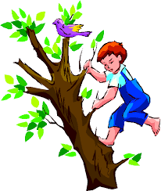
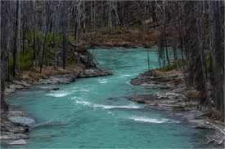
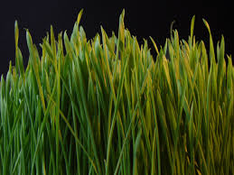
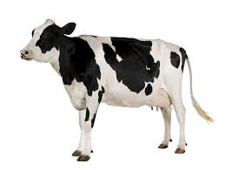
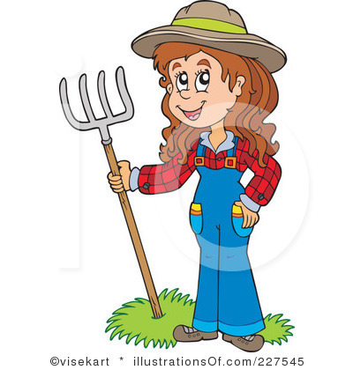

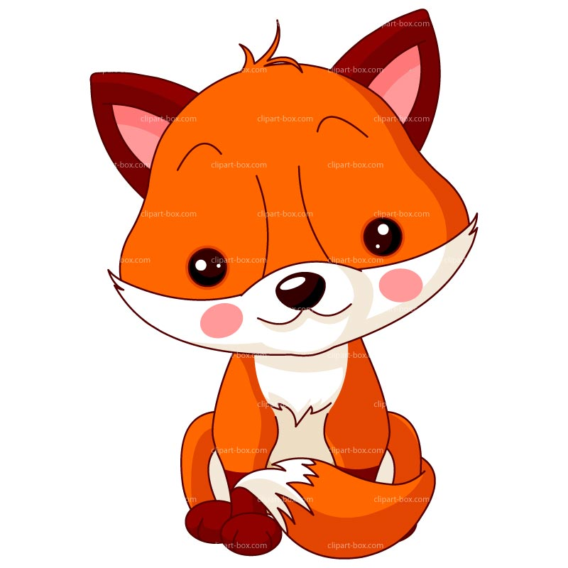

ASL 2

Homework and In Class

Worksheets

Name:_________________
Period:_______

