.
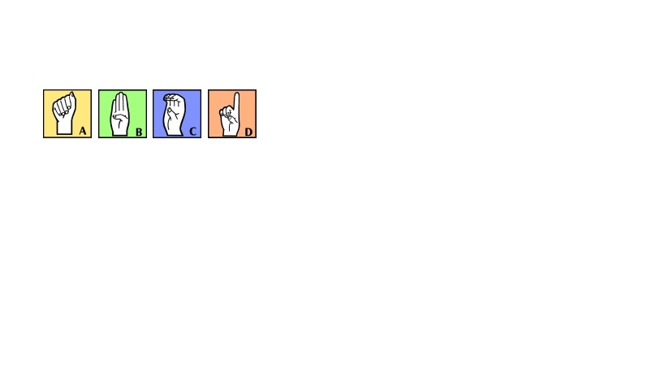
ASL 3 – American Sign Language
Mount Si High School
2015 -2016
Please keep this for
further reference
throughout the year.

Teacher: Lindsay Greene
Room: 302
Email: greenel@svsd410.org
Website: lindsaygreene.weebly.com
COURSE DESCRIPTION & GOALS
Course Description: This course expands on the concepts and language learned in American Sign Language (ASL) 1 & 2. As a third year class student interaction and participation will be required. You will be responsible for all content learned in ASL1& 2. Above all, this is a class that requires your attendance and practice outside the classroom environment. Success in this class will bring you valuable skills which will allow you to interact with another culture, by deepening your understanding of a unique, diverse, rich culture that coexists throughout North America, namely the Deaf community. This will enable you to broaden your understanding of deaf culture, communication, and language. ASL 3 is a foreign language accepted by many colleges and universities all over the country. Upon successful completion of this course with a letter grade of B or better you will be eligible for CTE College credit. This course will be more rigorous than the previous classes. It is KEY that students put both time and effort into outside practice and utilization of ASL.
Educational Philosophy: ASL cannot simply be learned in the classroom. It takes outside practice and exposure to others who sign. You will be given opportunities for learning in class, before and after school, and within the community. The more you put into my class the more you will get out of it. The possibilities are limitless.
Learning Styles: I hope that you will commit to creating a classroom environment which will accommodate persons of diverse backgrounds, experiences and needs. If you are able to appreciate, respect, and benefit from the varied personalities and behaviors of your peers, then you will be better prepared to do the same with the myriad encounters you will have with members of the Deaf community and our society as a whole.
Course Goals: During this year you will be asked to demonstrate your (1) expanding and growing receptive and expressive accuracy in and/or (2) knowledge of each of the following grammatical, functional, and cultural components of ASL:
Language Components
Core Vocabulary – Signing Naturally Units 13-17
Number 100+
Hand Shape Stories
Inflection with Temporal Aspect
Cheers and Songs
Poetry
Money Three Digit Numbers
Addresses
Phone Numbers
Manual Alphabet – Finger Spelling Accuracy and Fluency
Numbers – Cardinal Numbers, Ordinal Numbers 1-9, Ages, Ranking
Sign Parameters (Hand Shape, Orientation, Location, Movement)
Non-Manual Grammatical Signals (NMGS)
Classifiers – Pronominal, Size and Shape Specifiers, Locatives
Spatial Agreements – Eye-gaze
Distance
Real World Orientation and Signer’s Perspective
Key Concepts in Text
ASL Time Line and Time Indicators
Locative Language
Getting Directing and Maintaining Attention
Controlling Pace of Conversation
Resuming Conversation
Drama
Cultural Components
History of ASL
Deaf Culture and the Deaf Community

Deafness- What is it?

Audisim

Cultural exposure

REQUIRED MATERIALS
Textbooks/Digital Copies:
Signing Naturally Student Workbook and Videotext Units 13-17: Lenz, Mikos, Smith; Dawn Sign Press, second edition.

A Loss for Words The Story of Deafness in a Family By: Lou Ann Walker

Deaf Like Me By: Thomas & James Spradley

1in. three ring binder exclusively for ASL.

The use of your student email address and Google Drive.

SUPPLEMENTAL MATERIALS
There are no additional materials required, however it will be helpful for you to invest in or use any of the following resources (I will have copies available in the classroom):
Sign Language Dictionary: There are several sign language dictionaries available at bookstores and libraries. There is no one complete ASL dictionary, and some signs vary from book to book.
EVALUATION AND GRADING
Assignments – You should expect to spend about 40 min a night working on ASL related assignments. Assignments will include the Signing Naturally workbook and video assignments, summaries, and other assignments as carried out through the year.
Quizzes – There will be weekly quizzes. These quizzes will cover material from Signing Naturally and readings. If you are absent for a quiz (Fridays), the makeup will be Monday at 2:20 pm. Please make arrangements with your ride to school to make it here on time. If you cannot make it please contact me in advance.
Exams- Exams will be given at the end of each unit and will continue to build throughout the semester on previous units. By the end of the year the final test will encompass all information found in units 7-12.
Projects- Projects will be assigned though out the year. They will emphasize the current and past units of study.
Cultural Experience- You will be asked to attend 3 deaf events per semester. There is a comprehensive list of reoccurring events on my web page and I will notify you are special events come up. You also may want to join the Bellevue College ASL Club Facbook page.
End of Course Project- This project will take all that you have learned in both ASL1, ASL2 and ASL 3 to demonstrate all that you have learned.
GRADING POLICY
Grading- I do my best to get grading done daily. However, there are times when meetings, conferences and other responsibilities may delay a grade getting in. It is my personal goal to never have an assignment take more than 5 school days to get into the grade book.
Late Assignments- Late assignments will be accepted for 1/2 credit until the end of the each quarter.
Missed Quizzes/ Assignments – All make-up work is the responsibility of the student. You must check in with me (before or after class) and on the website to get handouts or other materials. I will not track you down.
CELL PHONE POLICY
I appreciate the need for cell phones in our society today. However, there is no need to use them in my classroom, unless directly instructed. I will give a warning, after that, the second offense will result in an office referral for a 1 hr. detention.

Student Name:__________________________________________

American Sign Language 3
Lindsay Greene
Room 302

Please return with both the signature of the student and a parent or guardian’s. Parents please do not hesitate in contacting me with any questions or concerns. By signing this page you are stating that you have read and understand the contents of the syllabus.

The return of this paper will count for a 10 point homework assignment.
Please return this by September 12th, 2014.

X
Parent Signature Date
Parent Phone Number: ________________________________________
Parent Email: ________________________________________________________

X
Student Signature Date

